**MACHINE LEARNING APPROACH FOR CLASSIFICATION AND IDENTIFICATION OF BLOOD CELLS**

*Praburam K Varadharajan,*

*UG Student,*

*Department of ECE,*

*Coimbatore Institute of Technology,*

*Coimbatore, INDIA.*

*1904034ece@cit.edu.in*

*Ms.K.Harini*

*Assistant Professor,*

*Department of ECE,*

*Coimbatore Institute of Technology,*

*Coimbatore, INDIA.*

*kharini@cit.edu.in*

**Abstract**: In the medical field, blood testing is considered one of the most important clinical examinations. A complete blood cell count is important for any medical diagnosis. Traditionally we use manual equipment to do this task which is time-consuming. Therefore, there is a need to research for an automated blood cell detection system that will help physicians to solve the problem efficiently. This paper presents a machine learning approach for the automatic identification and classification of three types of blood cells using a Single-shot MultiBox detector (SSD) network. This framework has been trained on the BCCD Dataset of blood smear images to automatically identify Red blood cells, White blood cells, and platelets.

1. **Introduction:** In the medical field, blood testing is considered one of the most important clinical examinations. A complete blood cell count is important for any medical diagnosis. The main three types of cells that constitute blood are red blood cells (RBCs), white blood cells (WBCs), and platelets. Change in the cell count may lead to various disorders like Myelosuppression, Pancytopenia, Anemia, Granulocytopenia**,** etc. in the human body. Therefore, it is necessary to keep track of these three types of blood cells.

With the development of machine learning techniques, image classification and object detection applications are becoming more robust and accurate. As a result, Machine learning-based methods are being applied in different fields. Particularly deep learning methods are being applied in medical fields such as abnormality detection and localization in chest X-rays [10], automatic segmentation of the left ventricle in cardiac MRI [11], and detection of diabetic retinopathy in retinal fundus photographs [12]. Thus, we also can use deep-learning-based methods to get a complete count of blood cells from blood smear images.

A complete blood count (CBC) is a group of tests (test panel) that gives information about the cells and cell count in a patient's blood. Earlier cell counting in a patient's blood was performed manually, by viewing a slide of the patient's blood sample under a microscope. Nowadays, this process is generally computerized which is done by using an automated analyzer, and only 10-20% (approximately) of samples are manually examined. Abnormally high or low counts may indicate the presence of many forms of disease or illness, and hence blood counts are mostly preferred to analyze the blood cells, as they can provide us with a rundown of a patient's general wellness.

In this paper, a deep learning-based blood cell counting method has been proposed. We employ a deep learning-based object detection method to detect different blood cells. Among the state-of-the-art object detection algorithms and methods such as regions with convolutional neural network (R-CNN) and You Only Look Once (YOLO) [16], Single-shot Detectors (SSDs) [13], we choose SSD framework with VGG-16 architecture. We retrain the SSD framework to automatically identify and count RBCs, WBCs, and platelets from blood smear images.

Here, Section 2, consists of a brief discussion about the previous work done for cell detection in microscopic images of blood. Section 3 describes the proposed model and the techniques involved in object detection in detail. The results of the experiments are discussed in Section 4 to show the efficacy of the proposed approach. Section 5 includes the conclusion of the work along with a brief discussion about future directions.

1. **Related works:** In general, there are generally two different approaches in the automated counting process of blood cells. They are the image processing approach and the machine-learning approach. **Mohammad Alam** proposed a similar kind of approach using ‘You Only Look Once’ Algorithm to detect and count blood cells [4].

**Wang** et al. [1] proposed a New Detection Algorithm (NDA) for white blood cells detection in the automatic recognition systems of microscopic blood images. NDA was compared with TSMM and Fuzzy Logic Method. NDA is based on fuzzy cellular neural networks. With this new algorithm, it can detect almost all white blood cells, and each detected cell is nearly complete. Its adaptability is strong and the running speed is comparatively high. The major drawback of NDA is that it could not distinguish the nucleus from the cytoplasm effectively.

**Cruz** et al. [6] presented an image processing system to count blood cells. They used hue, saturation, value thresholding method and connected component labeling for identification and counting of blood cells. **Lou** et al. [7] provided a method to automatically count RBCs using spectral imaging and Support Vector Machines (SVM). **Mausumi** et al. [2] presented a methodology to achieve an automated detection and counting of red blood cells in microscopic images using Hough Transform. It can also identify overlapping blood cells and count them separately. However, the software must be modified to count the effective number of RBCs that are partly in the image fields to obtain a more accurate result. Another drawback of the model is that it only identifies RBC and WBC, as well as platelets, which are not taken into consideration which should be worked on.

**Acharya** and **Kumar** [8] proposed an image processing technique to count RBCs using the K-medoids algorithm for extraction and granulometric analysis to separate RBCs from WBC’s and then counted using a labeling algorithm. **Zhao** et al. [15] proposed an automatic identification and classification system for WBC’s using Convolutional neural networks (CNNs). Firstly, they detected WBCs and then identified the type of WBCs. **Sobrevilla** et al. [3] presented a new approach to evaluating 70 images from a database collected at the Ellis Fischel Cancer Center of the University of Missouri. The results obtained by the proposed approach show the effectiveness of fuzzy techniques in vagueness treatment. Furthermore, the structural element is seen to be effective for segmentation based on pixel classification, when uniformity and gray level must be analyzed locally.

1. **Proposed model:**

Object detection can be used to count the number of objects in a particular image or scene. Using an image as input, for each target object (in this case, for example, the three types of cells above), we can individually determine- a rectangle with a minimum area encompassing the object (called a bounding box) and class label. The class is represented by an ID assigned to each object type (class label). For instance, RBCs are assigned 0, WBCs are assigned 1, and Platelets are assigned 2, with a non-negative integer corresponding to each object of the class. The Object Detection task results in a separate box for each instance, this type of output in technical terms is referred to as "instance-wise" object detection as shown in Fig. 1.

Our goal is to use the object detection and classification method SSD to detect and count blood cells directly from a smear image. We train the Single-shot MultiBox detector framework with the modified configuration and blood cell training images.

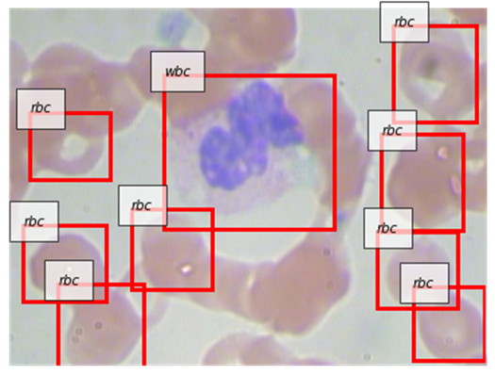

*Fig. 1. object detection (identified RBCs and WBCs). Input file with annotations.*

* 1. **Dataset:**

The dataset of blood microscopy images called the [BCCD dataset](https://github.com/Shenggan/BCCD_Dataset) [14] is an open-source dataset that is easy and can be downloaded from the internet. This dataset contains 364 images and an XML file with a file name corresponding to each image. In each image, the coordinates of the bounding boxes surrounding the RBC, WBC, and platelet cells are stored. As a single image may contain multiple cells, the XML file contains descriptions of multiple cells.

The first step is to prepare data which involves data visualization and data preprocessing, but as the data set used is quite small, much pre-processing is not required. Objects and classes are defined and the class contains three labels 0 for RBC, 1 for WBC, and 2 for platelets. Dataset is now split into training data, validation data and testing data with are approximately 56%, 23%, and 19% respectively. Fig. 2. Here shows the input data fed into the model.

|  |
| --- |
|  |

*Fig. 2. Blood smear images JPG file.*

* 1. **SSD:** Single shot Multi-Box detector [13] takes only one shot to detect multiple objects present in an image using a multi-box. First step is the feature extraction and that is done by using network architectures such as VGG and ResNet.. SSD is significantly faster in speed and high-accuracy object detection algorithm. A grid of anchor points is laid over input image boxes of multiple shapes and sizes that serve as a region for each box at the anchor point. The model output prediction of whether or not the desired object is present in the region.
     1. **Architecture:** VGG-16 base network [5] for SSD is standard CNN architecture for high-quality image classification but without the final classification layers as this network is used only for feature extraction. Additional convolutional layers are added for detection to the base of the VGG-16 layer. VGG-16 architecture consists of 13 convolutional layers, ReLU, Pooling, and 3 fully connected layers. Convolutional layers at the end of the base network decrease in size progressively. This helps with the detection of objects at multiple scales.
  2. **Training:** In this, feature maps are first extracted, then a candidate region is prepared for each position of the feature map. Each candidate region can have a different shape (square, vertical, horizontal, different sizes, etc. in the feature map. Then the candidate available that matches the correct answer the best is discovered, next, it calculates how much the candidate deviates from the bounding box of the correct answer and learns to minimize this deviation. At the same time, the system predicts the class of each object in the region and learns to minimize this error as well. If a candidate does not match any of the correct answers, we can predict that nothing was in that position.

The technique of applying various transformations to images and their associated labels without changing the meaning of the data (data augmentation) is a method that can be used to augment the training data. Different transformations are to be performed, for example, you can change the color of the image, flip it horizontally, or scale it up or down without changing its meaning. While doing so, the fact which should not be ignored is that if the image is flipped horizontally, the correct answer label should also be flipped horizontally. Another useful technique is to mask or hide a part of the image. This allows recognition to be based on a variety of information instead of relying on only one piece of information.

We apply these techniques and train the model on our dataset and after 300 epochs we get an accuracy rate for the 300 epochs from the validation data shown in Fig. 3.

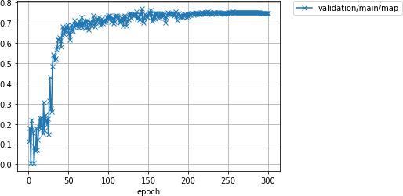

*Fig. 3. Accuracy (Validation data)*

* 1. **Evaluation metrics:** In object detection, the box that the model judges to be detected is equal to or greater than the correct box. The IoU in object detection is the size of the area enclosed by either or both the predicted rectangle and the correct rectangle divided by the size of the area enclosed by the common rectangle. The average precision (AP) is generally used for evaluation. We calculate the average absolute error between ground truths and the estimated number of cells in the validation dataset. The error is calculated using

(1)

Where *cell* indicates the type of cell (RBC, WBC, or platelets), N is the size of the validation dataset, in our case it is 84 images. *X* is the number of cells, is the average absolute error value for the particular cell.

The proposed model’s performance criteria in similarity to the actual data was determined based on accuracy and precision in equation 2-3.

(2)

(3)

The detection is considered a true positive (TP) only if confidence score bigger than %30 threshold and the predicted class matches the class of a ground truth and the predicted bounding box has an IoU greater than a %50 (IoU > 0.5) threshold with the ground-truth. If the predicted class do not match the class of a ground truth and the predicted bounding box has an IoU smaller than a %50 threshold with the ground-truth this violation makes a false positive (FP). In case multiple predictions correspond to the same ground-truth, only the one with the highest confidence score counts as a true positive. When the confidence score of a detection that is supposed to detect a ground-truth is lower than the threshold, the detection counts as a false negative (FN).

Once training is complete, the resulting model can be evaluated on a test dataset. The validation dataset is not directly used to calculate the number of parameter updates during training, but it is used to adjust hyperparameters such as the learning rate and the ratio and timing of learning rate decay. In the model used for the given data set, 300 epochs were executed with 1922 iterations.

1. **Results:**

With the proposed method, we automatically identify and count RBCs, WBCs, and platelets. We test our model using a test dataset of 72 images where the ground truths are known. After implementation and evaluation, the results obtained from the model are collected and analyzed. Table 1, below gives the accuracy values for the prediction of RBC, WBC, and platelets.

*Table 1. Accuracy values for Platelets, RBC, and WBC.*

|  |  |
| --- | --- |
| **Cell Type** | **Accuracy** |
| Platelets | 0.4308 |
| RBC | 0.7561 |
| WBC | 0.9657 |

The results displayed here shows that the prediction for white blood cells is the most accurate, followed by red blood cells, while the prediction for platelets is much lower than the other two. To analyze this problem further, we need to check whether platelets, red blood are considered to be "True Positive" when it is cells, and white blood cells appear in the dataset at the same frequency. If the frequency varies greatly from class to class, then the model is probably observing the less frequent class less often than the more frequent class. For a more practical real-world application, it is important to train the detector on a well-known model and produce results

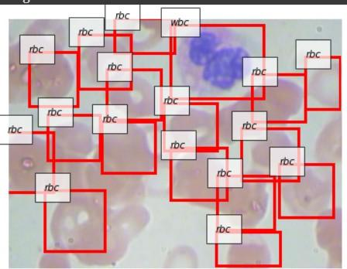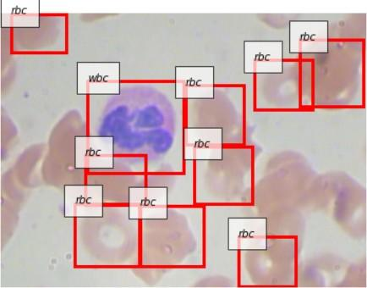

*Fig. 3. Prediction by model on our data.*

1. **Conclusion:**

Here the SSD model was implemented to identify blood cells so that the manual work can be reduced and also to minimize Human Error. The results indicate that the model performed excellently for WBC whereas the values for platelets were quite low. This shows the scope of improvement. One way is to work on the frequency of all the classes, but it is not in our control. For the class imbalance problem, a simple and powerful method called [Focal loss](https://arxiv.org/abs/1708.02002) has been proposed. The other solution which can be implemented is that, when training an object detector for real-world applications, it is important to first train the detector on a well-known model and produce results, and then compare the results with the data to examine the prediction tendencies of the model and the characteristics of the data set itself. Kaur et al. [9] proposed a method to count platelets by applying circular Hough Transform (CHT) in microscopic blood cell images. They used the size and shape of platelets from the transform for the counting process.

With the proposed method, it can be said that the method has the potential to ease up the manual blood cell identification and counting process of RBCs and WBCs.

1. **Reference:**
2. Wang Shitong and Wang Min**.** IEEE Transactions on Information Technology in Biomedicine, Vol.10, No. 1, January 2006.
3. Mausumi Maitra, Rahul Kumar Gupta, Manali Mukherjee. International Journal of Computer Applications (0975 – 8887) Volume 53– No.16, September 2012.
4. Sobrevilla, P., Montseny, E., & Keller,J. (n.d.). White blood cell detection in bone marrow images. 18th International Conference of the North American Fuzzy Information Processing Society - NAFIPS (Cat. No.99TH8397) Mohammad Mahmudul Alam, Mohammad Tariqul Islam.,
5. Mohammad Mahmudul Alam.:’Machine learning approach of automatic identification and counting of blood cells’, Healthcare Technology Letters, 2018..
6. Simonyan K., Zisserman A.: ‘Very deep convolutional networks for large scale image recognition ’. Proc. Int . Conf. Learning Representations, San Diego, 2015.
7. Cruz D., Jennifer C., Valiente L.C.: ‘Determination of blood components count in microscopic images using image processing and analysis. Proc. Int. Conf. on Humanoid, Nanotechnology, Information Technology, Communication and Control, Environment and Management, December 2017.
8. Lou J., Zhou M., Li Q.: ‘An automatic red blood cell counting method based on spectral images’. Proc. Int. Congress on Image and Signal Processing, Biomedical Engineering and Informatics, October 2016.
9. Acharya V., Kumar P.: ‘Identification and red blood cell automated counting from blood smear images using computer-aided system’, *Med. Biol. Eng. Comput.,* 2018.
10. Kaur P., Sharma V., Garg N.: ‘Platelet count using image processing, Int. Conf. on Computing for Sustainable Global Development, March 2016.
11. Islam M.T., Aowal M.A., Minhaz A.T.: ‘Abnormality detection and localization in chest X-rays using deep convolutional neural networks ’, 2017.
12. Avendi M.R., Kheradvar A., Jafarkhani H.: ‘A combined deep-learning and deformable-model approach to fully automatic segmentation of the left ventricle in cardiac MRI’. *Med. Image Anal.,* 2016.
13. Gulshan V., Peng L., Coram M.: ‘Development and validation of a deep learning algorithm for detection of diabetic retinopathy in retinal fundus photographs’, *J. Am. Med, Assoc.,* 2016.
14. Wei Liu., Dragomir Anguelov., Dumitru Erhan.: ‘SSD: Single Shot MultBox Detector’, December 2016.
15. BCCD, Blood Cell Images, Available online: URL <https://github.com/Shenggan/BCCD_Dataset>.
16. Zhao J., Zhang M., Zhou Z.: ‘ Automatic detection and classification of leukocytes using convolutional neural networks’, *Med. Biol. Eng. Comput., 2017.*
17. Redmon J., Divvala S., Girshick R.: ‘You Only Look Once: unified, real-time object detection, IEEE Conf. on Computer Vision and Pattern Recognition, December 2016.